**Customer Shopping Data Set- Retail Sales Data**

This report analyzes the Customer Shopping Dataset to uncover insights into revenue patterns, customer behavior, and seasonal trends. The analysis involved data cleaning, exploratory data analysis (EDA), and answering three key research questions using visualizations created in Power BI.

**Data Cleaning**

Before conducting the analysis, the dataset was cleaned to ensure accuracy and consistency:

**Handled Missing Values:** Checked for missing values in key columns like Product Category, Price, Quantity, Age, and Shopping Mall. Imputed missing values where necessary or removed incomplete rows.

**Standardized Formats:**

* Converted date fields (e.g., Invoice Date) into a proper date format for time-series analysis.
* Standardized categorical data (e.g., ensured consistent spelling in Product Category and Shopping Mall columns).

**Created New Columns:**

* Added a Revenue column by multiplying Price and Quantity.
* Extracted Month and Year from Invoice Date for time-based analysis.

**Removed Outliers:** Analyzed numerical columns (e.g., Price, Quantity, Age) for outliers and adjusted extreme values affecting the analysis.

**Exploratory Data Analysis (EDA)**

The following analyses were performed on the cleaned dataset:

* **Revenue Distribution:** Identified the contribution of different shopping malls to total revenue.
* **Category Performance:** Analyzed revenue generation by product categories.
* **Customer Demographics:** Examined shopping patterns by gender and age groups.
* **Time-Series Analysis:** Explored revenue trends over months and years to uncover seasonality.

Key measures used:

1. Total revenue.
2. Average spending per customer.
3. Payment method preferences.

**Business Questions:**

* Which product categories generate the highest revenue across different shopping malls?
* What are the shopping patterns across age groups?
* How does revenue fluctuate over time (monthly/yearly trends)?

**Research Questions and Insights**

Below are the research questions, Power BI charts (visualizations), and key insights derived:

**Q1:** Which product categories generate the highest revenue across shopping malls?

* A stacked bar chart revealed that **Clothing and Shoes** are the highest revenue-generating categories, with Clothing performing exceptionally well in malls like Istinye Park and Forum Istanbul.
* **Cosmetics and Food & Beverage** showed moderate revenue contributions, while categories such as **Technology, Souvenirs, and Books** contributed the least across all malls.
* **Insight:** Focus marketing efforts on underperforming categories (e.g., Books and Technology) while leveraging the popularity of Clothing and Shoes to drive further sales.

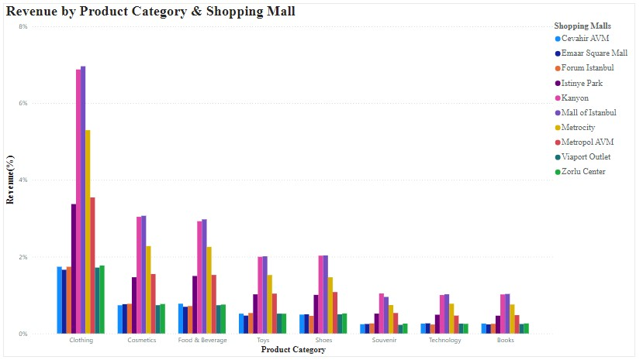

**Q2:** What are the shopping patterns across age groups?

* The **pie chart** reveals nearly equal revenue contributions from males (49.91%) and females (50.09%), suggesting a balanced shopping trend across genders.
* Gender does not show a significant influence on total revenue generation, implying that both male and female customers contribute equally to overall sales.
* **Insight:** Marketing campaigns can be designed to appeal equally to both genders, with no need for heavy gender-specific targeting, ensuring inclusive promotional strategies.

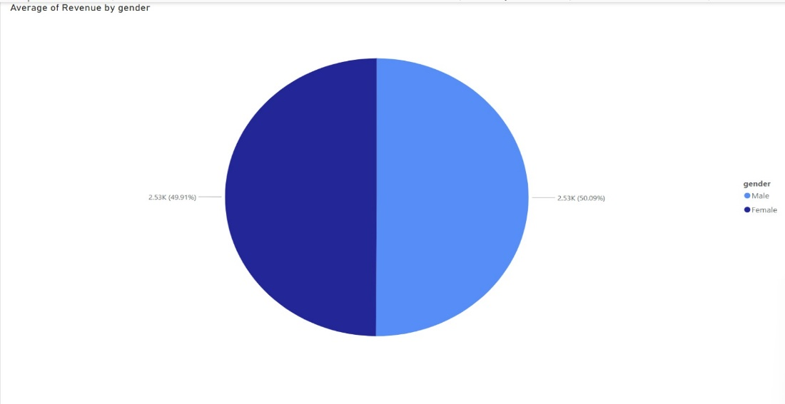

**Q3:** How does revenue fluctuate over time (monthly/yearly trends)?

* The **bar chart** highlights that total revenue remained consistent between **2021** and **2022**, with both years generating approximately **115M** in revenue.
* **Seasonal Peaks:** Revenue consistently peaks during November and December, aligning with holiday shopping periods.
* **Mid-Year Decline**: A noticeable dip in revenue occurs during the summer months, particularly in July and August, suggesting a seasonal slowdown.
* **Year-over-Year Growth:** Comparing data from 2022 to 2023 indicates a steady increase in monthly revenue, reflecting overall business growth.

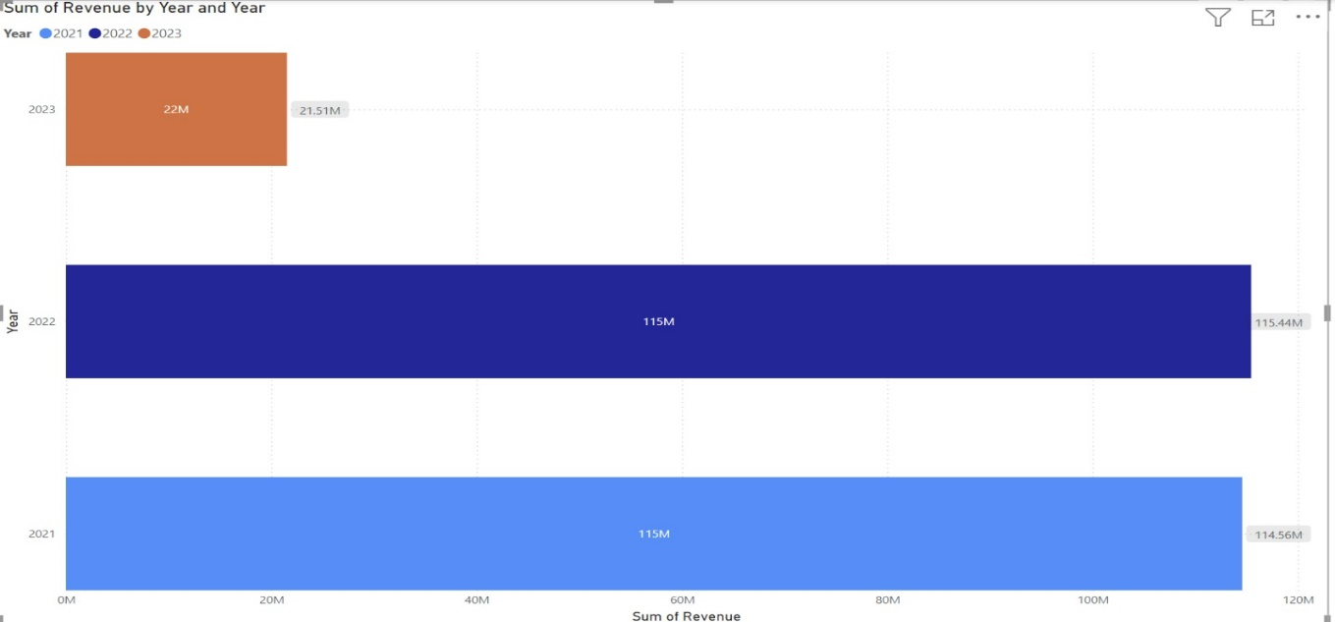

**Strategic Business Recommendations**

* **Focus on Top Categories:** Invest in marketing and inventory for Shoes and Clothing, as they are the highest revenue generators, while implementing targeted strategies to boost underperforming categories like Books and Accessories.
* **Optimize Seasonal Campaigns:** Leverage the holiday shopping season (November–December) by running promotions and increasing stock, and develop strategies to mitigate the revenue dip during summer months.
* **Cater to Diverse Demographics:** Maintain gender-neutral product offerings and tailor campaigns to appeal to all age groups, ensuring inclusivity and maximizing customer reach across shopping malls.